**Task11-Gemini**

**Tables vs. <div> Elements for Layout in CSS**

**Tables** were originally designed for presenting tabular data, but they were often misused for creating page layouts. While possible, using tables for layout can lead to complex and inflexible structures, especially when dealing with dynamic content.

**<div> elements** are more versatile and modern for creating layouts. They are block-level elements that can be styled and positioned using CSS properties like display, float, position, and flexbox.

**Example HTML Document**

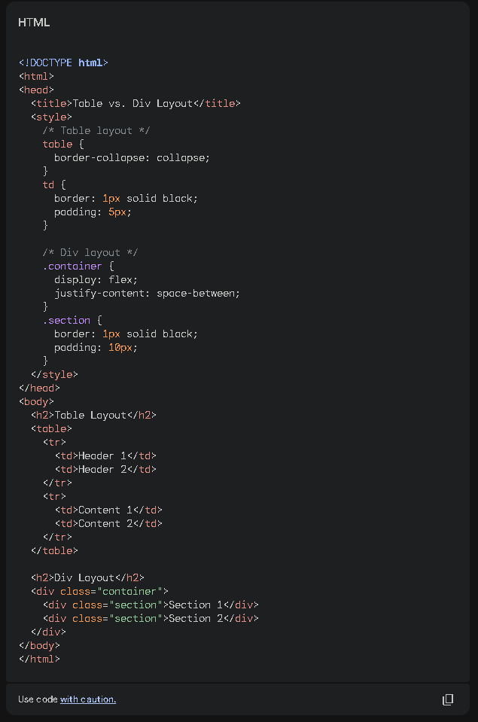

Result:

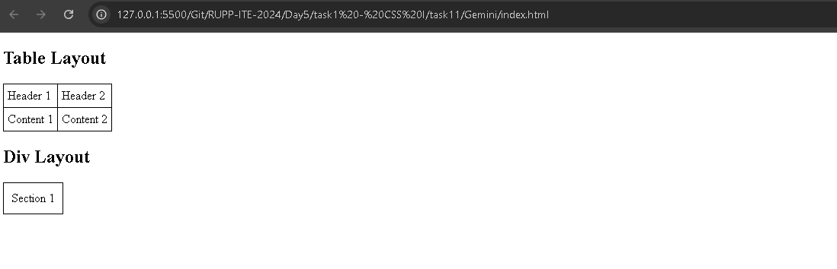

### When to Use Tables vs. <div> Elements

* **Use tables for:**
  + Presenting tabular data (e.g., spreadsheets, schedules)
  + Simple, fixed layouts that won't change significantly
* **Use <div> elements for:**
  + Complex, dynamic layouts
  + Creating responsive designs that adapt to different screen sizes
  + Organizing content into logical sections

**Key Differences:**

* **Semantics:** Tables are semantically meant for representing tabular data, while <div> elements are more generic.
* **Accessibility:** Using tables for layout can be less accessible for screen readers and assistive technologies, especially if not used correctly.
* **Maintainability:** <div>-based layouts are often easier to maintain and modify, especially for complex structures.
* **Flexibility:** <div> elements offer more flexibility for creating various layouts using CSS properties like flexbox and grid.

**In conclusion,** while tables can be used for layout, it's generally recommended to use <div> elements for most modern web design purposes. They provide better flexibility, accessibility, and maintainability, especially when dealing with complex and dynamic layouts.